Stages of the database design
- conceptual
- logical
- physical

conceptual database is an overview for the database does not have in detailed information
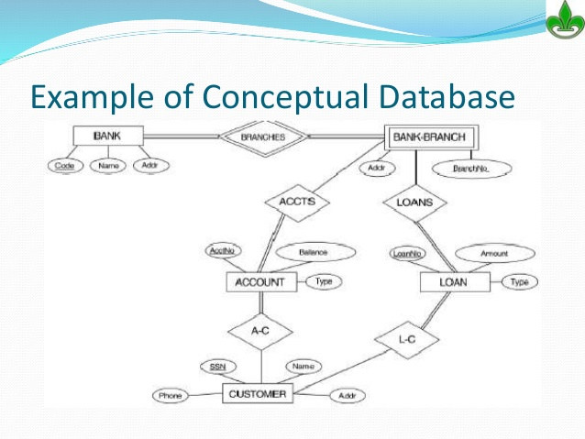

Logical Database is a detailed design for the database which shows how database tables relate to each other

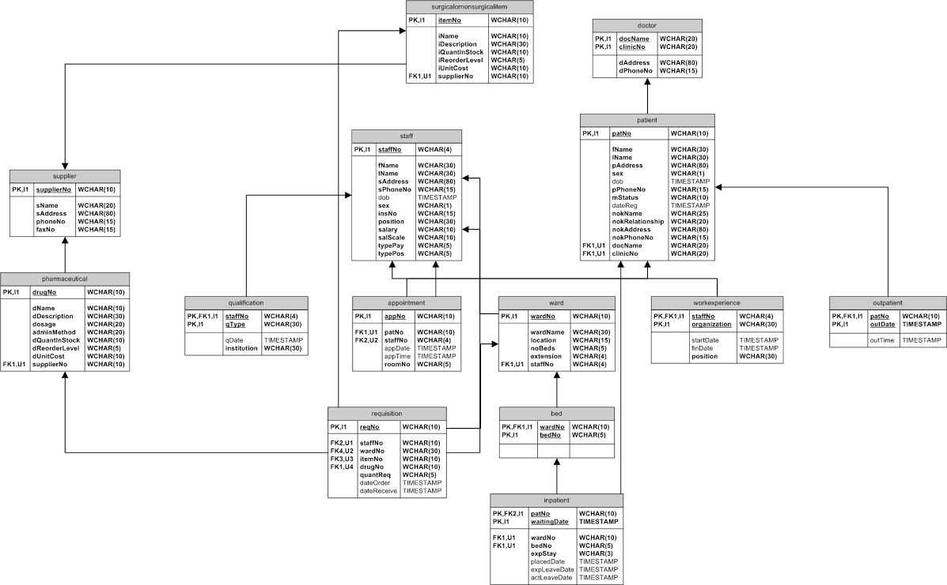

physical database is the lowest level of the databases in which we choose the DBMS and which server will we use

**************************************************************************

Database integrity

Entity integrity is that the entity has a unique attribute that prevents data duplication
in this case we use an existing attribute as SSN or we create one as ID

Referential integrity when table has attribute that refer to another table so the related table must be updated
what if the one table deleted ?
What is the relation down ?

Domain integrity what type of data valid
what if user inter wrong data type ?

